Basic process:

1. Edit the notebook in Jupyter on your computer
2. Go to GitHub Desktop application
3. Type a commit message
4. Commit the changed files in your csx4501 repository by clicking on the Blue commit button
5. Then push to GitHub (blue button to push origin)
6. Check your repository on <https://github.com> to make make sure the changed files are there
7. Submit the assignment by entering the URL for your repo
8. 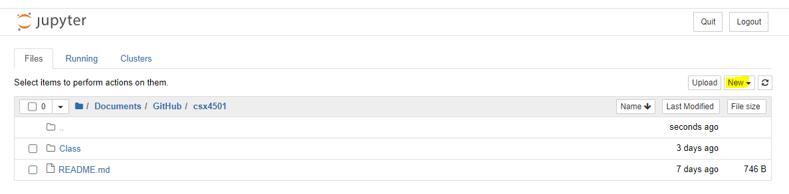

<https://chartio.com/resources/tutorials/excel-to-mysql/>

Upload excel to mysql